Application form
To apply for a place on one of my courses or workshops, please compete this form and send to t2c@helencottrill.co.uk. By submitting this application and/or paying the deposit you are accepting the terms and conditions, so please read and sign.
Course or workshop name (i.e. Senior Practitioner)
Start Date
Personal details
First Name
Surname
Address
County |  |  | Postcode
Telephone
Mobile
Email
Invoice details (if different from above)
Please note that the application form cannot be processed until ALL invoice details outlined below are provided.
Name
Company Name
Address
County |  |  | Postcode
Telephone
Email
Purchase Order No. (if applicable)

How did you hear about this programme?

If someone recommended the programme to you, please tell us their name

Any other special requirements (e.g. large print, dyslexia support, etc):

Your prior learning and experience
This information provides evidence that you are eligible to join this level of coaching programme (senior practitioner), plus it supports your accreditation of prior learning and experience, should you wish to apply for the EMCC EIA option now or later.
Please state the approximate total HOURS previous experience of counselling, coaching or other one-to-one conversations, such as mentoring:
____________hours (state number of hours), which I have delivered over a period of:
1 year 3 years 5+ years Other ……………….

What relevant course/s or development programmes have you previously attended (please list)?
Current Employment
Job Title/Occupation
Company Name
Address
County |  |  |  | Postcode
Telephone
Email
What is your counselling/psychotherapy modality or tradition?
Professional membership
Please confirm your membership of the following professional counselling or psychotherapy bodies (please note we will ask to see copies of your membership document):
Professional body
UKCP registered member number
BACP registered member number
Other* (please state):
(If ‘other’, we may ask you to complete a competency mapping form.)

Personal Statement
The statement should be approximately 250 words long. Please give the following information in support of your application:

- Why you are applying for this particular programme
- What you hope to achieve through studying this programme
- How you feel your past / current studies / experience support your application
- How this programme is relevant to your future career/professional goals
- How ethics and diversity currently inform your practice
- Any additional information that you feel is relevant

Terms & Conditions
This agreement has been designed to protect the quality of the training you receive on our courses and workshops.

Payment for Training
Applications for a place on one of my courses or workshops will only be considered when an application form is completed and received. The specified deposit of £900.00 (which forms part of the course fees) must be received with the application form in order to confirm a place on the course. Until such time as the deposit is received, Therapist to Coach Training may continue to sell or allocate places.
Payment Methods
Bank transfer is the preferred method of payment for course fees, including the deposit. The deposit can also be paid by card via the secure payment link, which accepts both bank transfer and card. The remaining course balance is payable by bank transfer; card payment for the balance may be available in exceptional circumstances on request.
Deposit & payment methods
A deposit of £900.00 is required along with this application form to secure your place on the course. Bank transfer is preferred, using the account details below. Payment for the remaining course balance will need to be paid 60 days prior to the course start date, by bank transfer, outlined in the follow-on invoice once accepted onto the course.
For Bank Transfer - Account Details:
Account Name: Therapist to Coach Training (Business account)
Sort code: 04-00-06
Account number: 22568282

IBAN: GB44MONZ04000622568282
BIC: MONZGB2L

For Deposit :
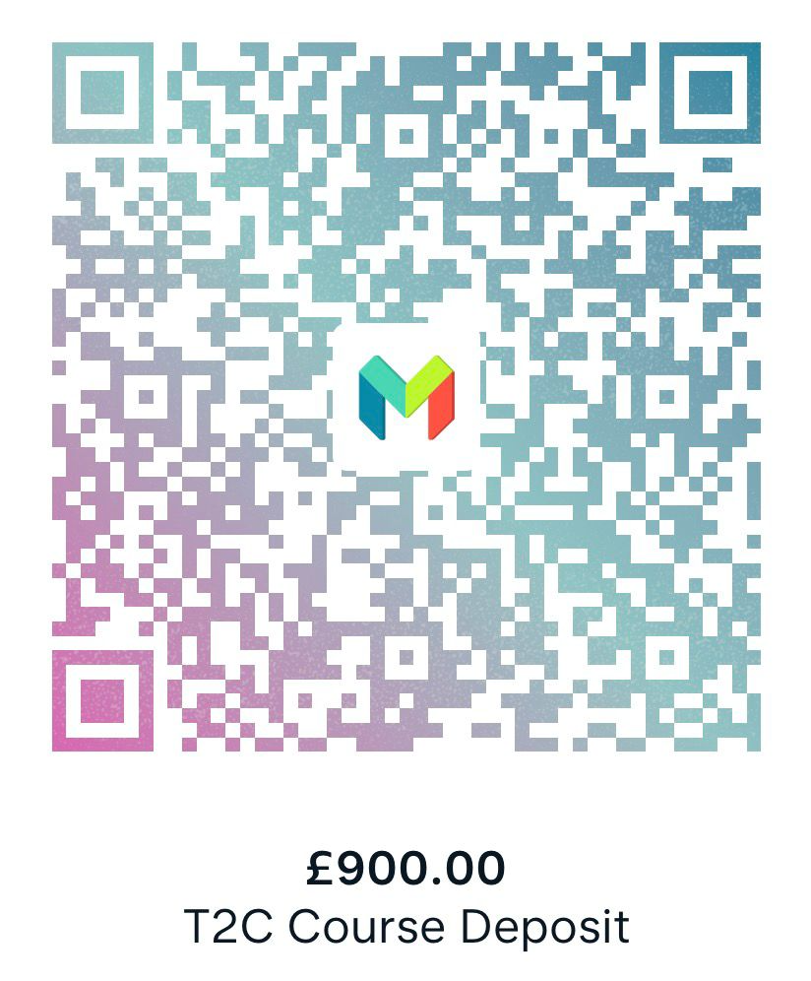 | Scan the following QR code to take you to the secure deposit payment page.

Where payment is made by debit or credit card, participants acknowledge and agree that:
- The payment is made voluntarily and in full agreement with these terms and conditions.
- No chargeback, payment reversal, or dispute will be raised with their card issuer in relation to a legitimate transaction. Any concerns or disputes must be raised directly to Helen Cottrill by email (see address below) in the first instance, in accordance with the complaints procedure.
- By completing card payment, the participant confirms they have read, understood, and agreed to these terms, and that the transaction is authorised.
- Therapist to Coach Training reserves the right to pursue recovery of any sums lost as a result of an illegitimate chargeback, including any associated bank fees, through the appropriate legal channels.
General Payment Terms
You will be sent invoices confirming the applicable payment amounts based on your chosen payment method. All course fees need to be paid 60 days prior to the course start date.
No participant may attend a workshop without payment of fees in full. Late payment of fees attracts an administrative surcharge of 10% of total course fee.
Cancellation by Participant

Each participant has the right at any time to cancel his or her place on the training course, programme or workshop. All requests to cancel must be made in writing to Helen Cottrill (email address below)
Received applications will be acknowledged via formal email by Therapist to Coach Training and be processed as below:

- On receipt of the application, it will be reviewed and, if the entry requirements are met, an acceptance letter via email by Therapist to Coach will be sent out.
- Cancellations received 91 or more days before the start of the training programme are not subject to a cancellation charge and any monies paid will be returned to you.
- Cancellations received less than 90 days before the start of the training programme are subject to a cancellation charge of 100% of total programme fees (i.e. no refund is payable).
- Participants who fail to attend the training programme or who withdraw from the programme after it has commenced are subject to a cancellation charge of 100% of total programme fees (i.e. no refund is payable).
- Therapist to Coach Training reserves the right to re-sell or re-allocate cancelled places.

Communication

Should a participant have any concerns relating to the programme I encourage you to raise them informally with the trainer(s) in the first instance, as I am always keen to receive feedback and, where possible, to resolve concerns quickly.

However, should a participant wish to raise concerns formally then she/he should write to Helen Cottrill by email (see address below).

The decision of the Programme Director, in relation to that letter or email, is final and there will be no further communication on the matter.

Cancellation by Therapist to Coach Training

Our programmes are designed so that participants can learn from one another as well as benefit from trainer input, and therefore each course or workshop will have a minimum cohort number to achieve this. When it is anticipated that we will not achieve the minimum number, programmes will be rescheduled or, if necessary, cancelled. In such cases, we will advise applicants as soon as practicable and offer alternative programme dates where possible.

Accreditation and Endorsement

The Senior Practitioner programme is accredited by the European Mentoring Coaching Council (EMCC Global) and has been granted the European Quality Award (EQA) award.

Therapist to Coach Training however cannot be held liable in respect of any decision, action or alteration to the course standards taken by the EMCC, which may have a subsequent effect of altering the status of the course offered by Therapist to Coach.

Please remember your payment and copies of your memberships and qualifications.

Please complete and sign the confirmation on the next page.

Confirmation
 |  |  | Tick
Yes. I acknowledge receipt of this agreement and confirm that I accept the terms and conditions set out in this agreement.
I have paid the specified deposit
I have paid the full course fees
Method of payment:

Bank transfer
Card Payment

Total amount paid £……………….
 |  |  | Tick
I have enclosed a copy of my professional membership(s)
I have enclosed a copy of my counselling/psychotherapy qualification(s)
Signed by the participant
Signature

Date |  | Name
Title (if relevant):
Signed for and on behalf of Therapist to Coach Training
Signature

Date |  | Name: Helen Cottrill
Title: Programme Director

PLEASE NOTE A SIGNED COPY OF THIS CONTRACT IS REQUIRED
Payment of the deposit is acceptance of the terms and conditions.
Contact details
Email: t2c@helencottrill.co.uk
Website: https://www.helencottrill.co.uk/therapist-to-coach-training

